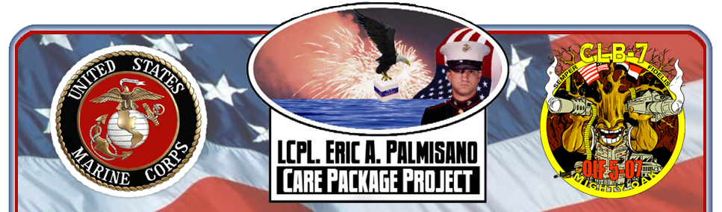

**Donations still needed to fill boxes and cover shipping costs. Suggested items include—**

* Money to cover shipping costs ($18.45 per box)
* Snacks (beef jerky, granola/nut bars, individually packaged Rice Krispy Treats or Pringles, trail mix, tuna snack packs)
* Puzzle books, games, puzzles
* Warm socks and gloves, hand warmers
* Good quality toilet paper
* Pocket size bibles
* Individual beverage mixes (coffee, hot cocoa, crystal light)
* Baby wipes, personal wipes
* Deodorant, lip balm
* DVD’s (comedies preferred)
* Books, travel games

**Join the Palmisano Care Package Project and the Trillium Area Girl Scouts for a holiday packing event**

**Saturday November 9th  9-11am**

**First Presbyterian Church**

**395 Hamilton Ave, Kingsford MI**

Join Girl Scout troop 5190 and the Trillium Area Girl Scouts in our goal to send 150 packages to the troops for the holidays. Have a service member abroad—bring their address! Questions about donations- contact Bobbie Samme (906)396-4900 or at courtroom@charter.net.